- Begin with a ball of clay that fits in the palm of your hand | - Press your thumb into the center of the ball (not all the way through)
 | 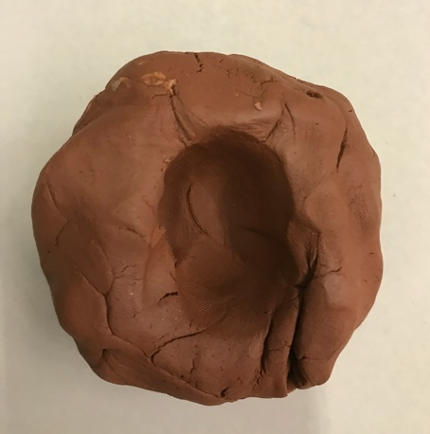
- Gradually press and smooth the sides into the desired shape and thickness | - Take a small amount of water and smooth the top edge and any other cracks
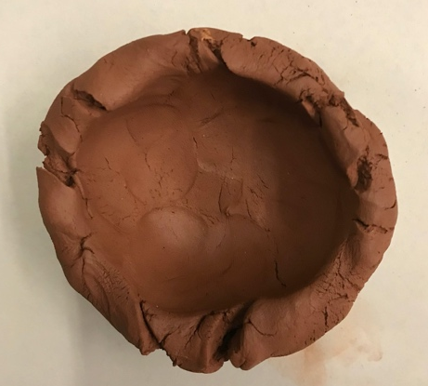 | 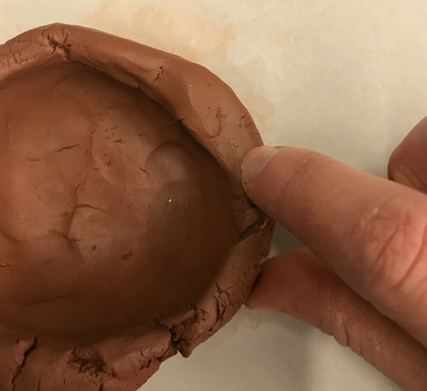
- Done! | - Make sure to scratch the student’s initials/name and year on the bottom with a wooden needle tool
 | 